Voting in a federal
by-election
24-1997 EF340 2026-03-30
A SOCIAL STORY

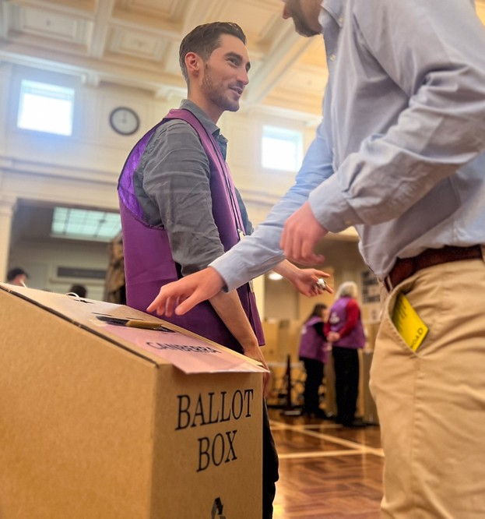
On election day, I will vote.
A by-election is held when there is an empty place in the House of Representatives.
When I vote in a by-election, I help to choose a new representative for the area I live. This is called an electorate.
My representative will be part of the Australian government.
The government makes decisions on our behalf about how to run the country.
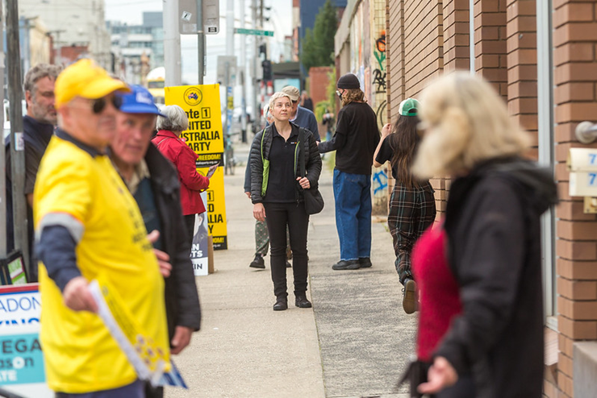
It’s important for me to have a say about who makes the decisions that affect me.
For me to make the best choice possible I can research the candidates or get advice from someone I trust.
My vote is secret. It’s my choice who I vote for, and I don’t need to tell anyone how I voted unless I want to.

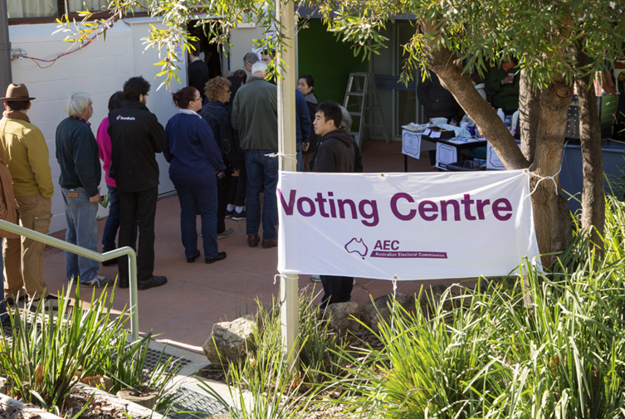
On election day, I will go to a polling place.
When I arrive at the polling place there might be a lot of people, and I might need to wait in a line.


It might be very noisy, and I might want to take ear plugs, headphones or a support person to help me.

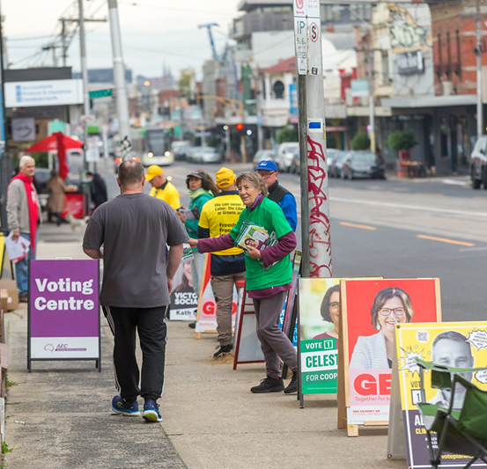
I might see people handing out pieces of paper. These pieces of paper explain how I might like to vote for a particular party.
I don’t have to take one if I don’t want to.
Who I vote for is my choice.

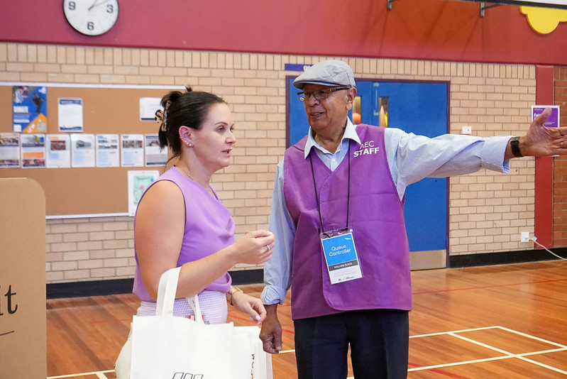
The Australian Electoral Commission, or AEC, is responsible for running the election.
When I go inside, I will speak to an AEC staff member in a purple vest with a lanyard around their neck. I can ask someone to help me at any time.

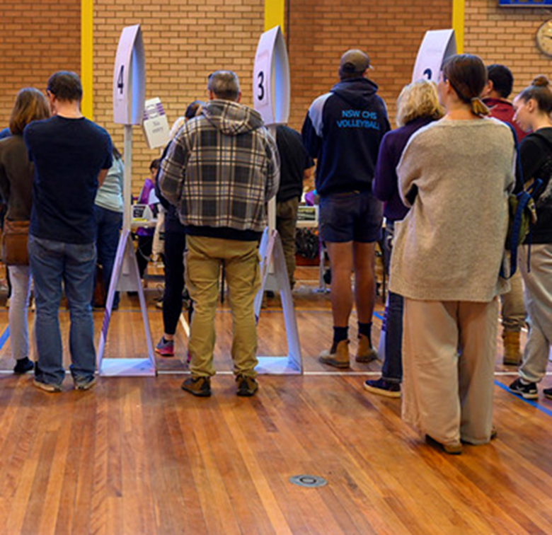
I might need to line up and wait for my turn before I get to vote.

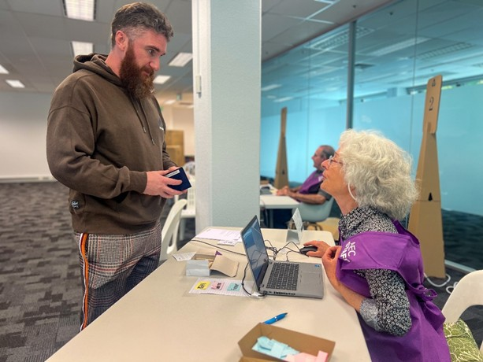
The staff member will help me find the table where I will speak to another AEC staff member.
This person will ask me 3 questions so they can find my name on the list.

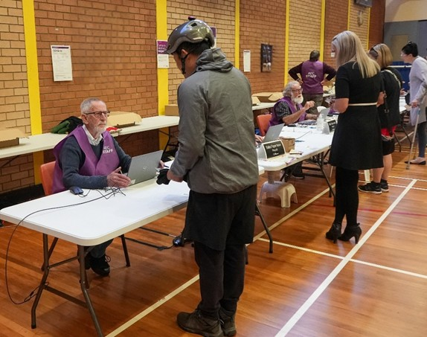
First, they will ask,
“What is your name?”
I need to tell them my first and last name.

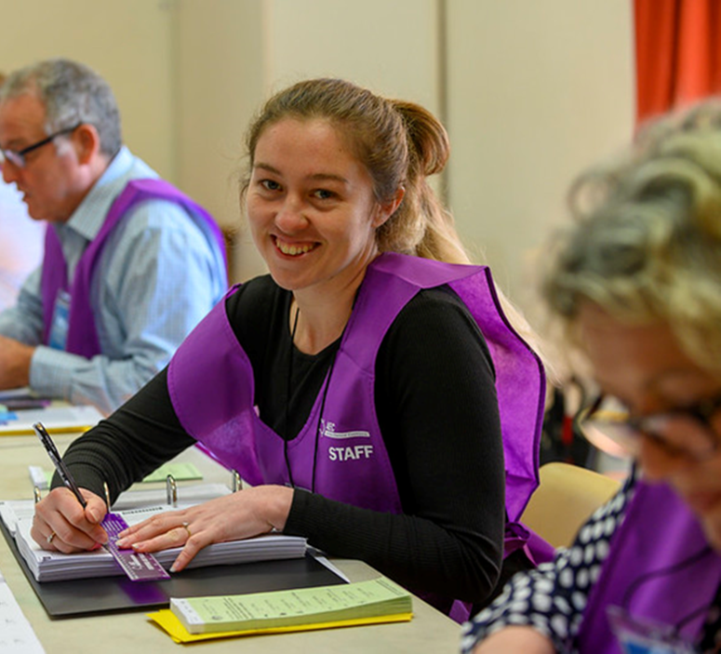
Next, they will ask,
“What is your address?”
I need to tell them the address I gave when I enrolled to vote. This address will probably be where I live.

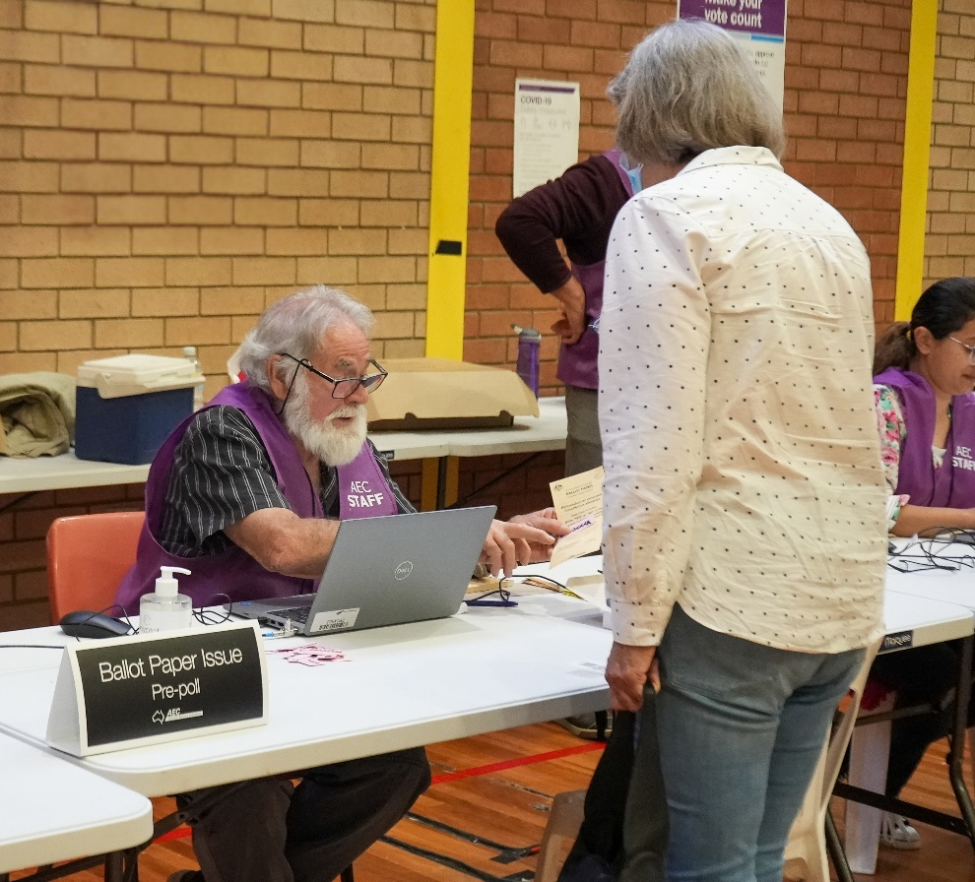
The third question they will ask is, “Have you voted before in this by-election?”
I need to say “No” if I haven’t voted in this by-election. I need to say “Yes” if I have already voted in this by-election.

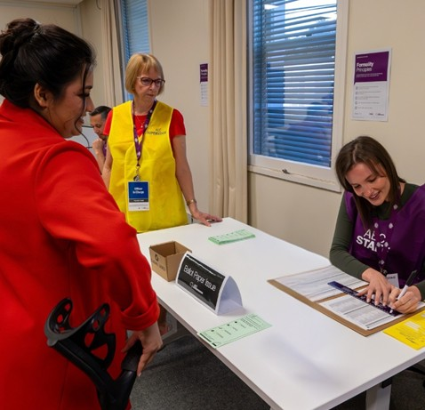
The AEC staff member will cross my name off the list.

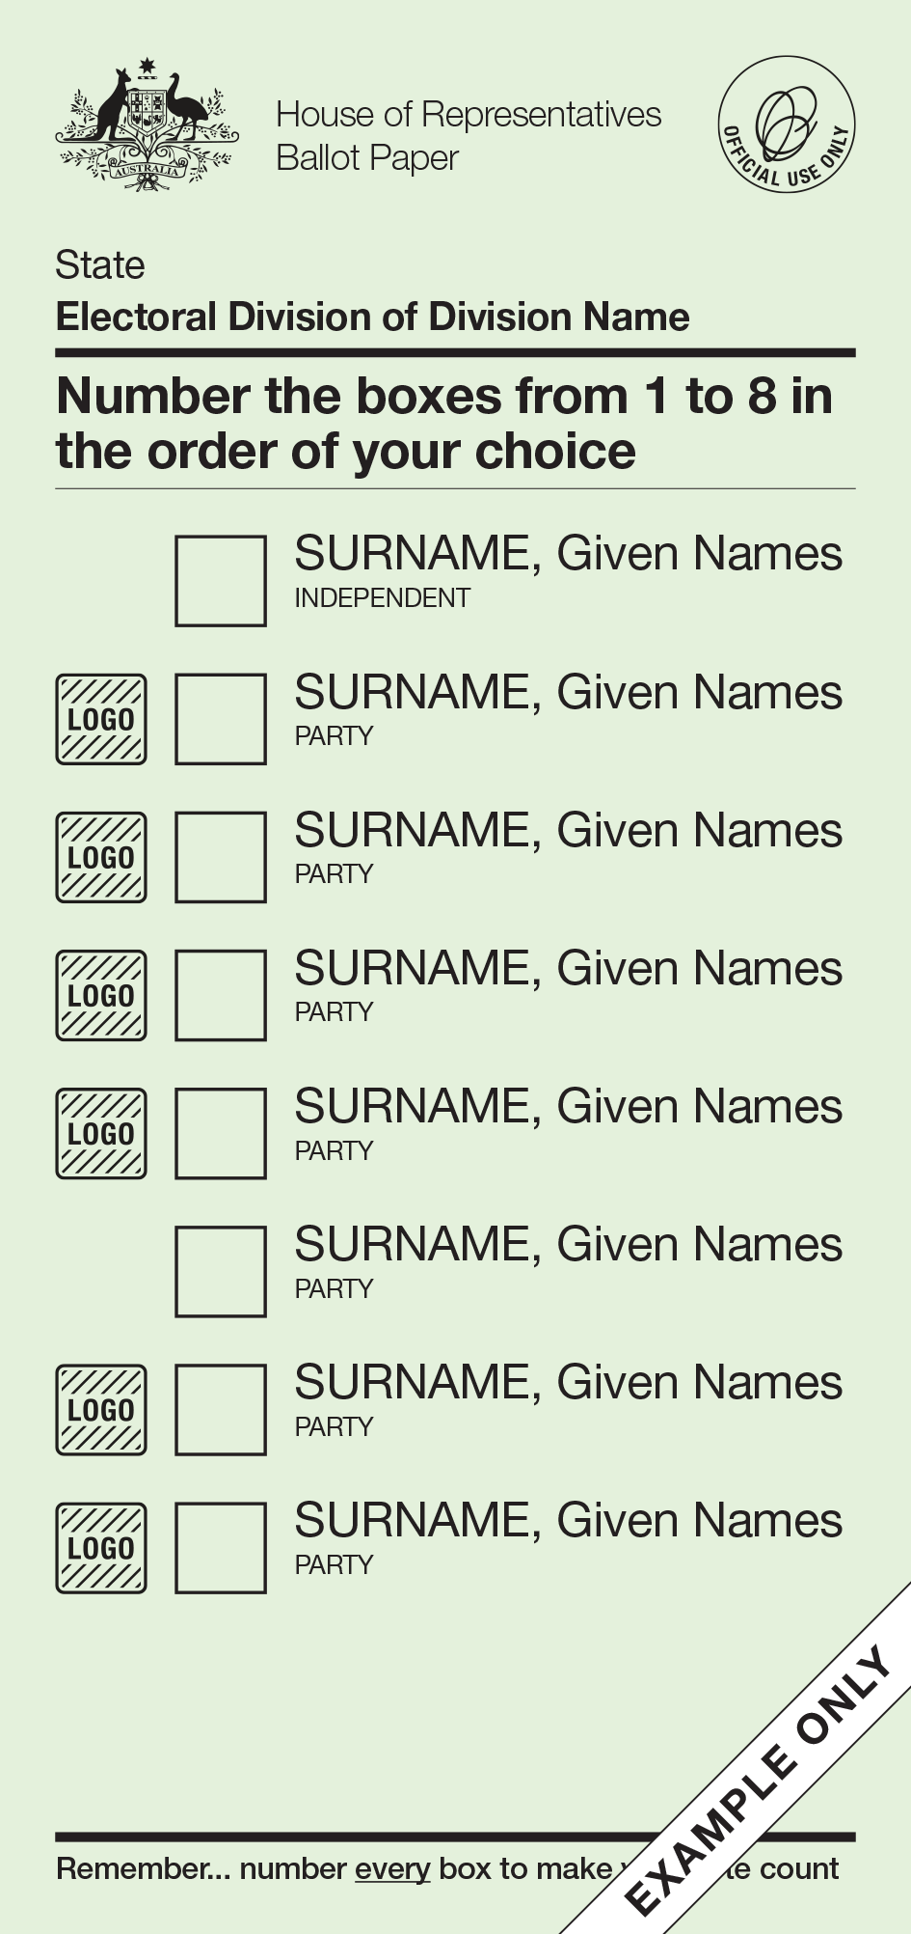
I will be given one green ballot paper.

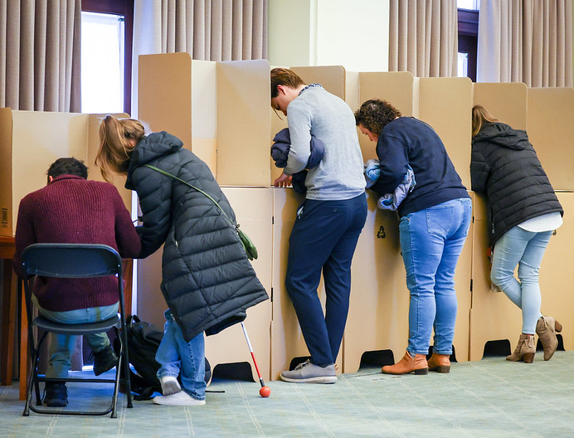
I need to take my ballot paper to the voting tables.
There will be a pencil for me to fill out the ballot paper. I can also bring and use my own pen or pencil if I want to.

The green ballot paper is for the House of Representatives, and it has a list of all the candidates I can vote for.
A candidate is a person who wants to be part of the Parliament.
If the candidate belongs to a political party, it will be written under their name.
On the green ballot paper, I need to write 1 in the box next to my favourite candidate, then 2 in the box for my second favourite.
There are instructions on the ballot paper telling me how many numbers to write.
I need to keep writing numbers until all the boxes are filled.

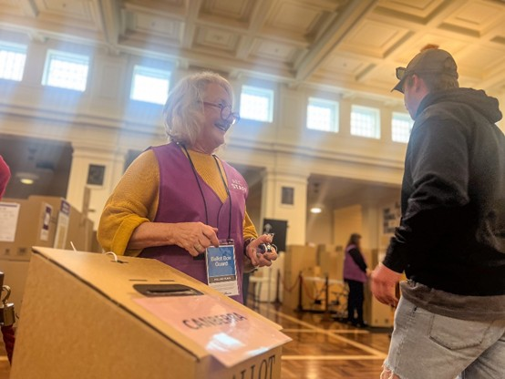
If I need help, I can ask one of the AEC staff or a friend or family member.
If I make a mistake on my ballot paper, I can take it back to the AEC staff member who gave it to me.


I can tell them I made a mistake and need a new ballot paper.
The AEC staff will:
- take the ballot paper with the mistake
- give me a new one
I will take the new ballot paper and fill it out.

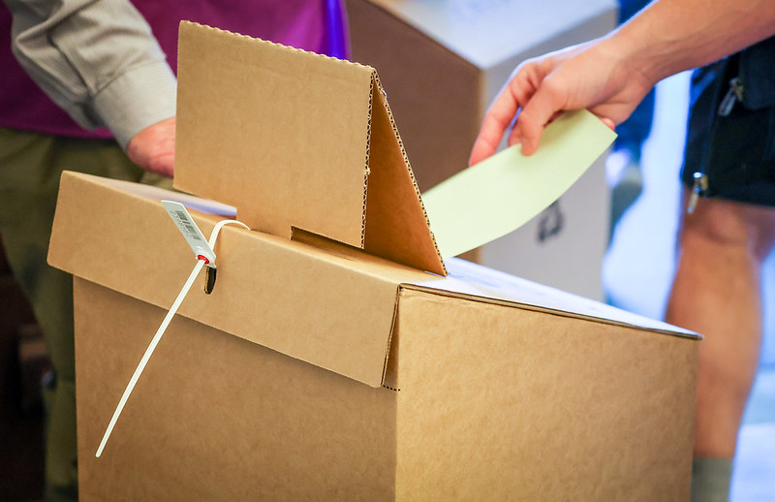
When I have finished filling out my ballot paper I need to put it in the ballot box.

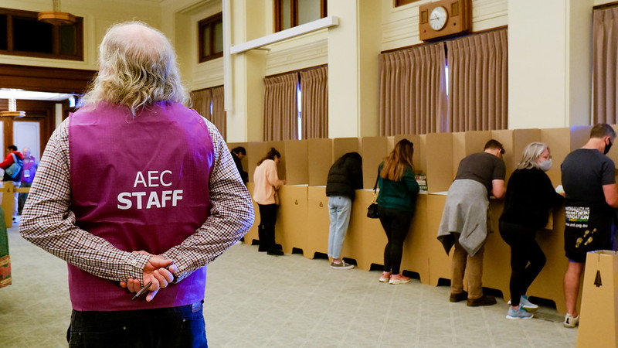
The AEC staff member can help show me how to put my ballot paper in the box.

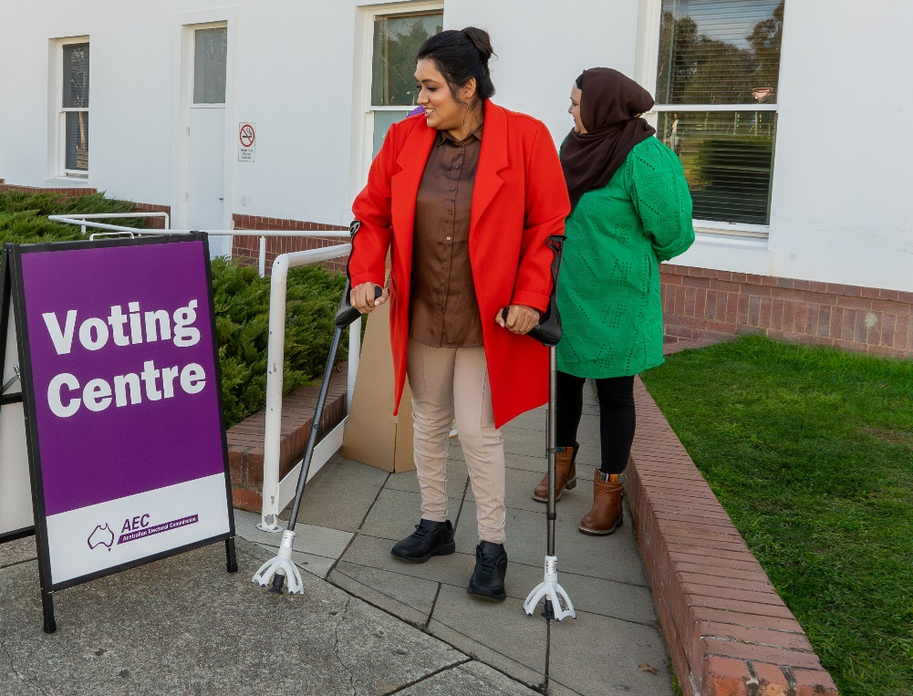
Now I have finished voting and I can leave.

